Test Case: tc001_SPX_Dev5_Crear_Solicitud_Articulo_Almacen
Step 1 - Enter username and password and click to button Enter : Credentials Entered
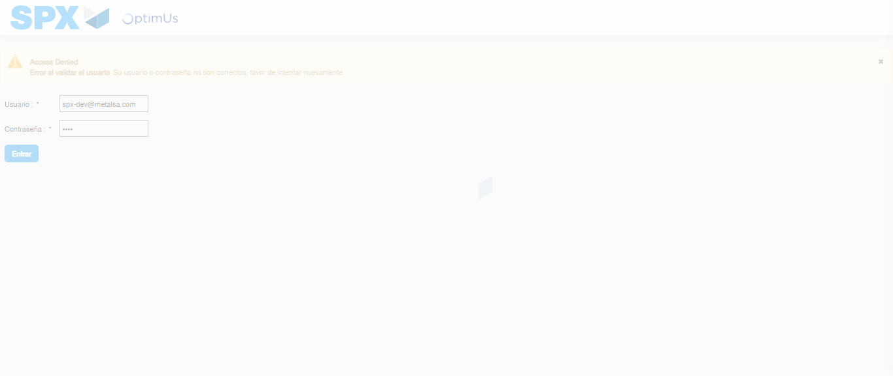Image file-name: QC_Testing-tc001_SPX_Dev5_Crear_Solicitud_Articulo_Almacen-1787930430042

Step 2 - Select to UEN and Access to Request for a New Inventory Item : UEN Correctly selected and Correct access
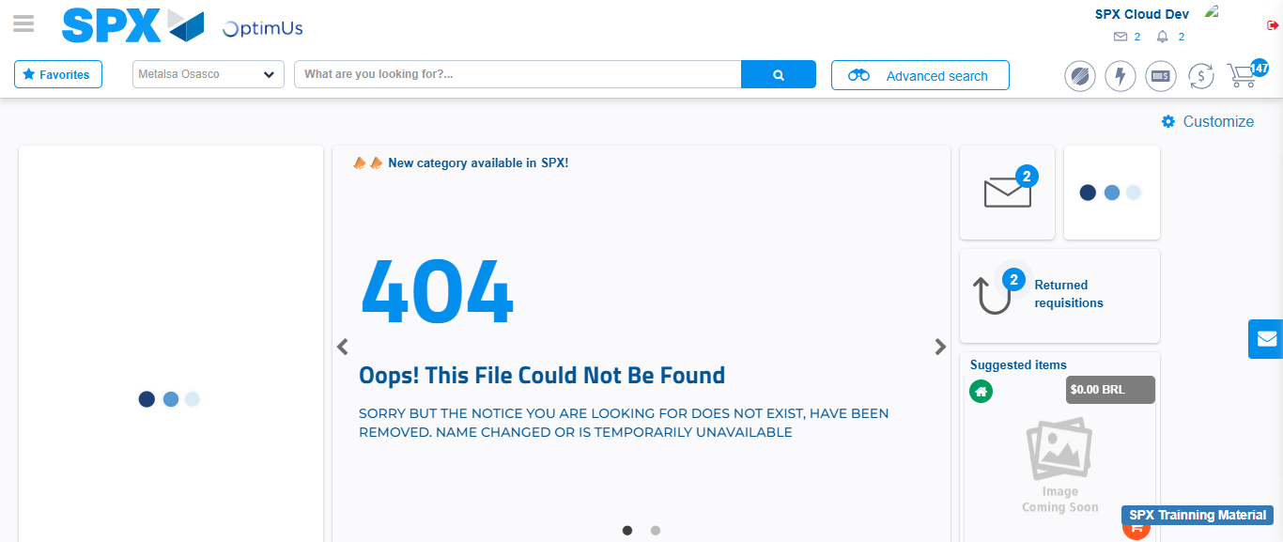Image file-name: QC_Testing-tc001_SPX_Dev5_Crear_Solicitud_Articulo_Almacen-1787930456548

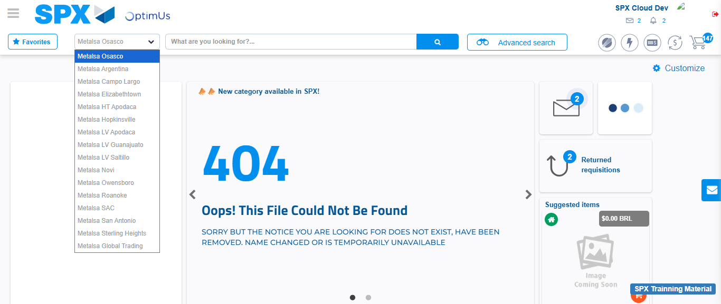Image file-name: QC_Testing-tc001_SPX_Dev5_Crear_Solicitud_Articulo_Almacen-1787930457090

Image file-name: QC_Testing-tc001_SPX_Dev5_Crear_Solicitud_Articulo_Almacen-1787930485557

Step 3 - Select options first section : Options seleted correctly
Image file-name: QC_Testing-tc001_SPX_Dev5_Crear_Solicitud_Articulo_Almacen-1787930485822

Image file-name: QC_Testing-tc001_SPX_Dev5_Crear_Solicitud_Articulo_Almacen-1787930486008

Step 4 - Select options at Screen: Options seleted correctly
Image file-name: QC_Testing-tc001_SPX_Dev5_Crear_Solicitud_Articulo_Almacen-1787930485822

Image file-name: QC_Testing-tc001_SPX_Dev5_Crear_Solicitud_Articulo_Almacen-1787930486008

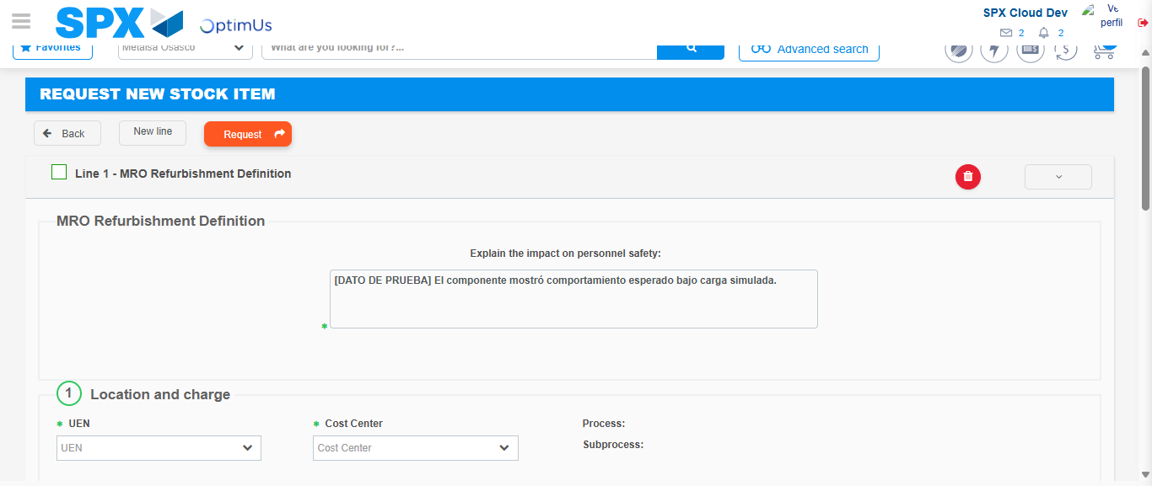Image file-name: QC_Testing-tc001_SPX_Dev5_Crear_Solicitud_Articulo_Almacen-1787930493018

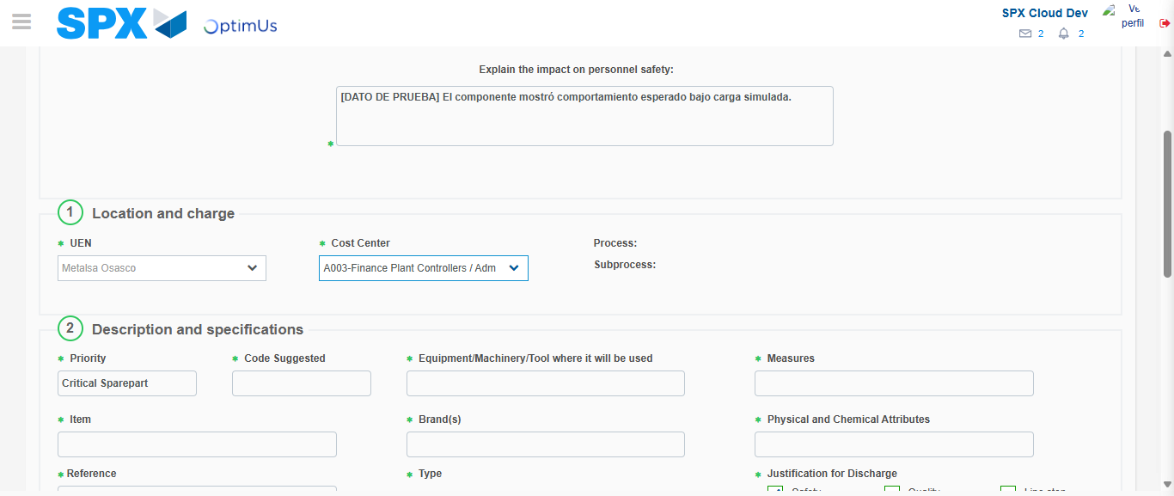Image file-name: QC_Testing-tc001_SPX_Dev5_Crear_Solicitud_Articulo_Almacen-1787930495846

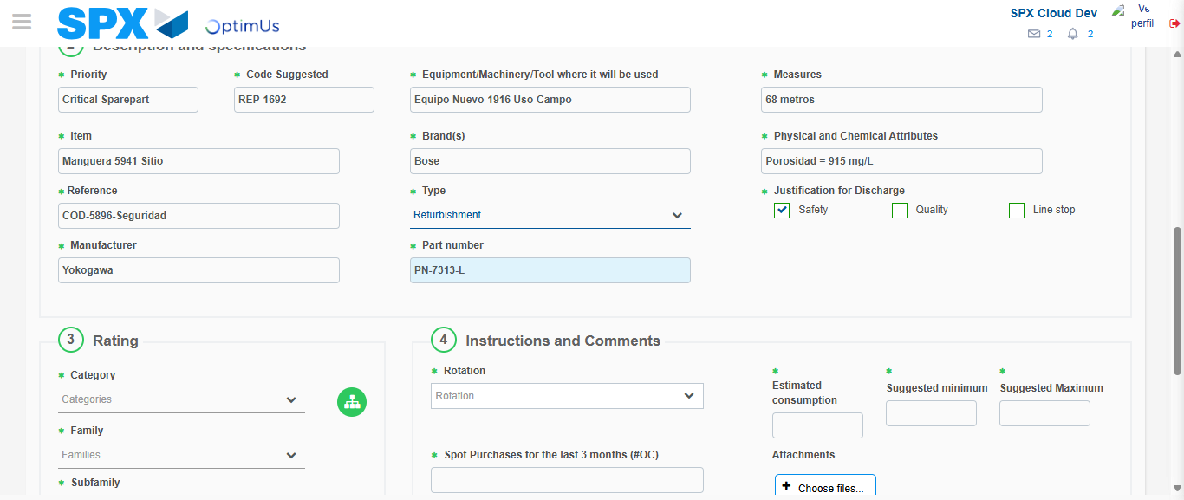Image file-name: QC_Testing-tc001_SPX_Dev5_Crear_Solicitud_Articulo_Almacen-1787930497709

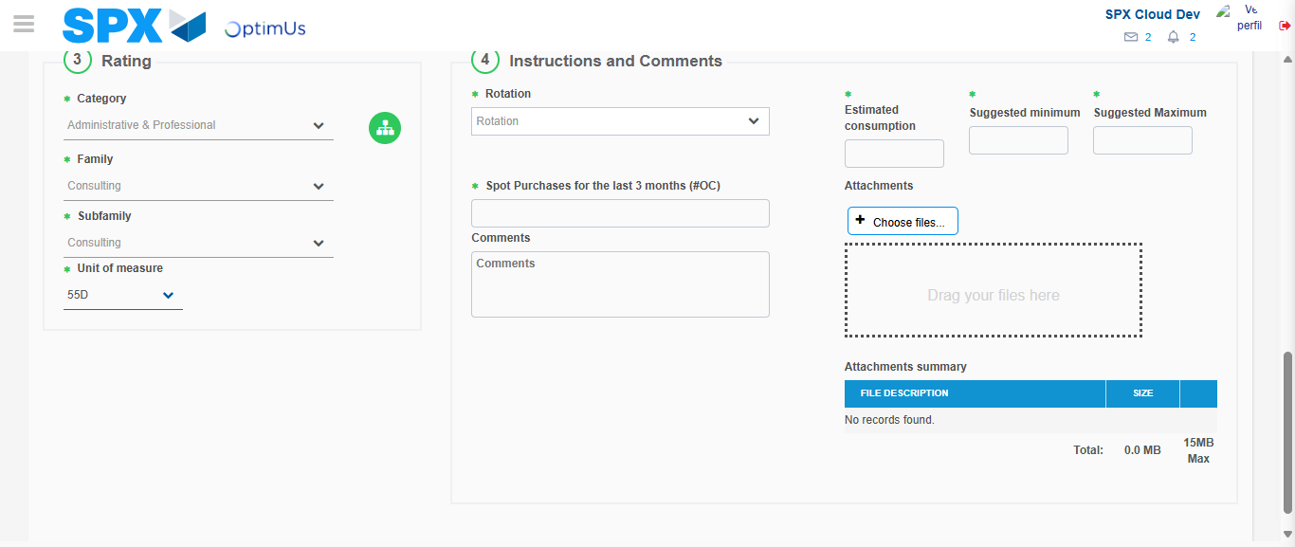Image file-name: QC_Testing-tc001_SPX_Dev5_Crear_Solicitud_Articulo_Almacen-1787930502545

Step 5 - Request New Item : Request Accepted
Image file-name: QC_Testing-tc001_SPX_Dev5_Crear_Solicitud_Articulo_Almacen-1787930456548

Image file-name: QC_Testing-tc001_SPX_Dev5_Crear_Solicitud_Articulo_Almacen-1787930457090

Image file-name: QC_Testing-tc001_SPX_Dev5_Crear_Solicitud_Articulo_Almacen-1787930485557

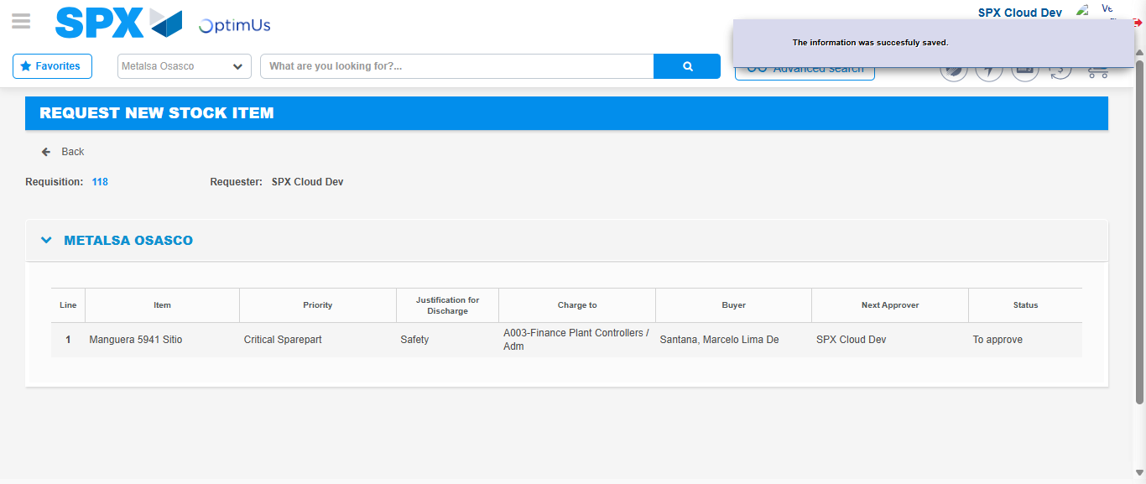Image file-name: QC_Testing-tc001_SPX_Dev5_Crear_Solicitud_Articulo_Almacen-1787930509236

Image file-name: QC_Testing-tc001_SPX_Dev5_Crear_Solicitud_Articulo_Almacen-1787930509426

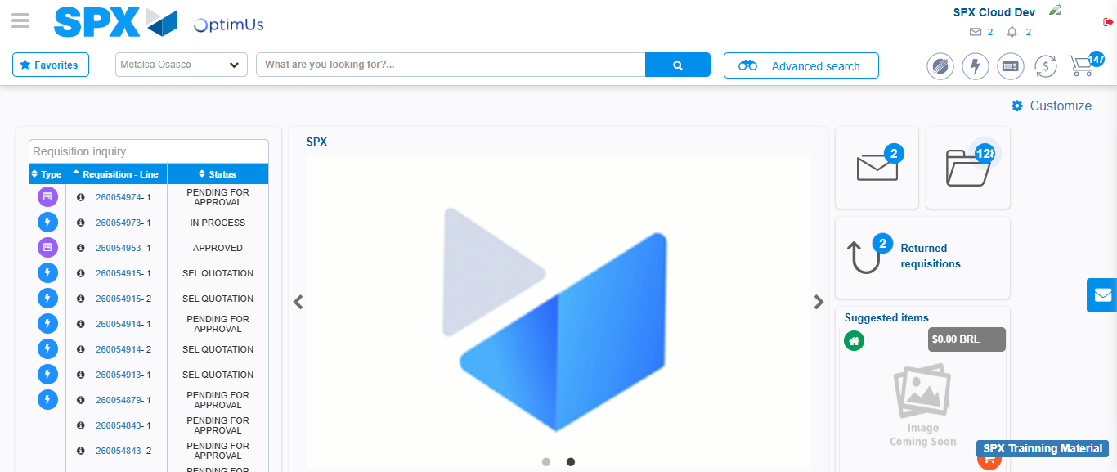Image file-name: QC_Testing-tc001_SPX_Dev5_Crear_Solicitud_Articulo_Almacen-1787930530727

Step 7 - Return to Main Page SPX : Return to Main Page SPX
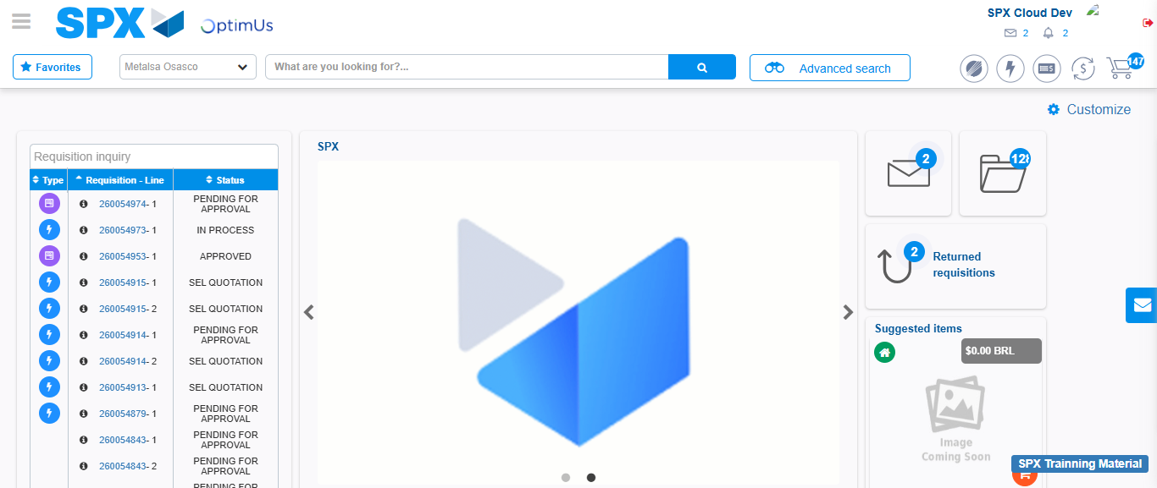Image file-name: QC_Testing-tc001_SPX_Dev5_Crear_Solicitud_Articulo_Almacen-1787930531034

